
Data, Analytics & Reporting Technology Services

How to run SQR Reports in PeopleSoft

1. INTRODUCTION

2. ACCESS AND RUN ADMISSIONS REPORTS

Create a Run Control ID

Run the Report

1. Introduction

In PeopleSoft, there are a number of reporting options available. These options include PSQuery and SQR Reports. This document specifically covers running the SQR Reports.

2. Access and Run Reports

From the MyCampus home page, select the MaineStreet Icon, then select:

Enterprise Applications > Campus Solutions-Reporting DB > University of Maine Systems >
From here, select the folder you need. For the example that follows, select Student Admissions>Reports>Admissions Report Home

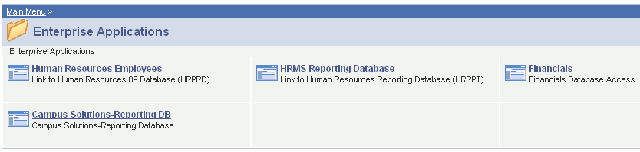

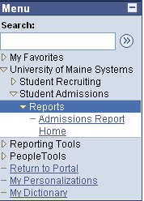

The Admissions Reports page opens:
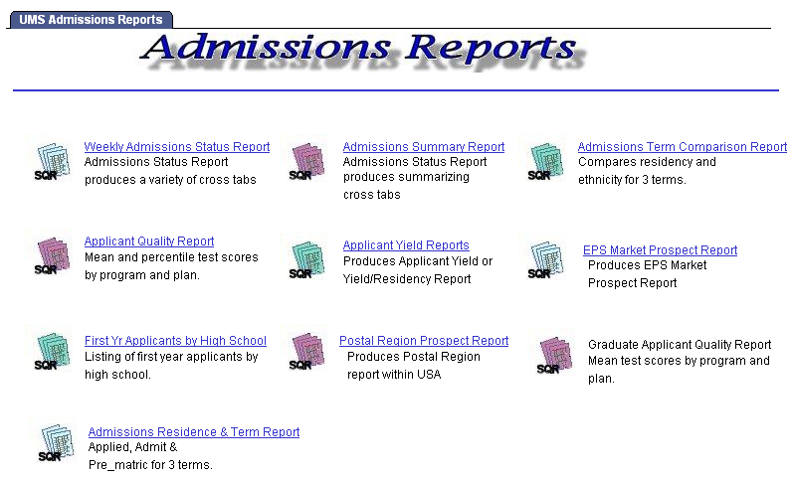

Select the link to the report

The Run Control ID page for the selected report opens:

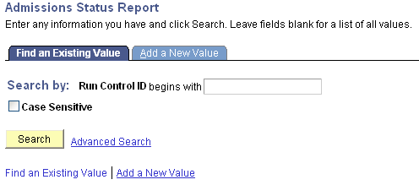

Create a Run Control ID

The first time you run a report you must create a Run Control ID. Run Control IDs are used whenever a process is run in PeopleSoft. They allow you to create, save and reuse a list of reports. Only you will see the Run Controls you create.

To create a new Run Control ID, select the Add a New Value tab.

After you have created Run Control IDs for this process, you will select the Find an Existing Value tab to look up the Run Control IDs. When you select a Run Control ID, it will take you directly to the page to run the process associated with it. If you only have one Run Control ID, the system will take you immediately to the Run Control page for that process when you select the Find an Existing Value tab.

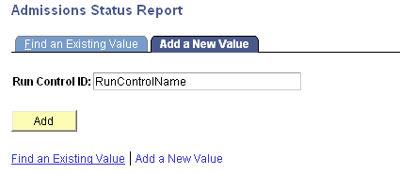
On the Add a New Value page, enter a name for the Run Control ID. You can use up to 30 alpha numeric characters (DO NOT use spaces). If you plan to run this report with the same parameters on a regular basis, apply a name that relates to the report.

Select
when ready.

The Run Control page for the selected report opens:
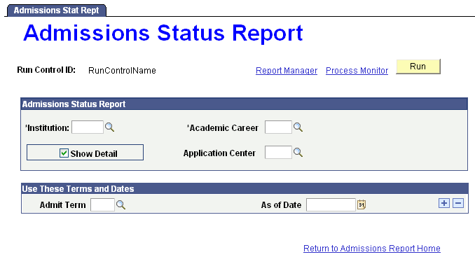

The parameters available for reports vary according to the nature of each report.
Enter the required parameters and select the button.

The Process Scheduler Request page opens.
Your User ID (7-digit Employee ID) will display on all pages.
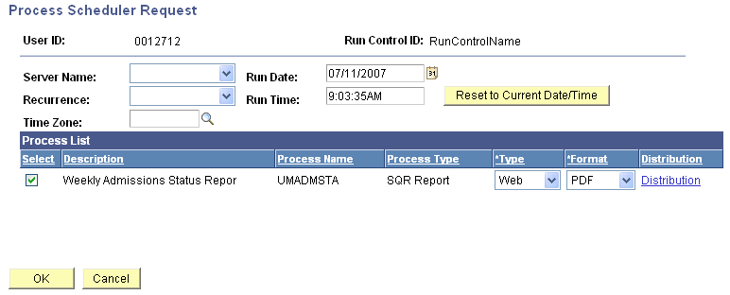

In the Process List section of the page, verify the report you want to run is checked in the Select column. The Process Type column shows whether it is a Crystal or SQR report. In the Format column, choose whether the report should be generated in PDF or Excel format.
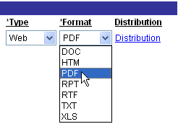

Select PDF, XLS or CSV.

You do not need to enter any other information on the Process Scheduler Request page.

Run the Report
Click when ready to run the report.
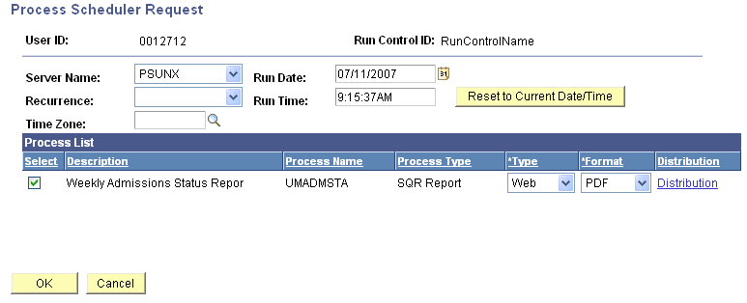

The Run Control page opens and you will see a Process Instance number has been assigned.

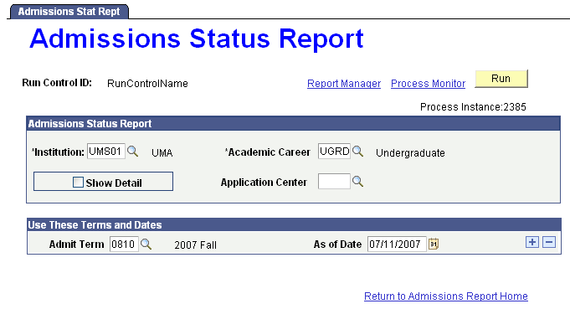

Select the Process Monitor link.

The Process List page opens:

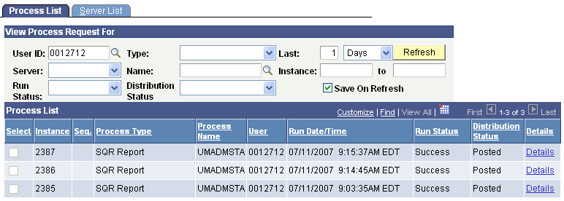

This is where you will monitor the status of your report and eventually access a link to it.

The Run Status will initially appear as “Queued,” then “Initiated,” then “Processing” and finally as “Success.” Select to update the information displayed in the Run Status column.

Once the Distribution Status is “Posted”, click the link to access the page where the report is listed.

You can access reports you have run up to ten days after the run date. To narrow or broaden the list of reports listed, adjust the settings entered in the “Last:” fields of the View Process Request For section.

After the Process Detail page opens, select View Log/Trace.
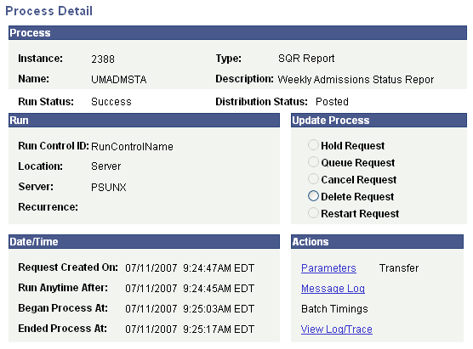

On the View Log/Trace page, select the output file from the list to open it.
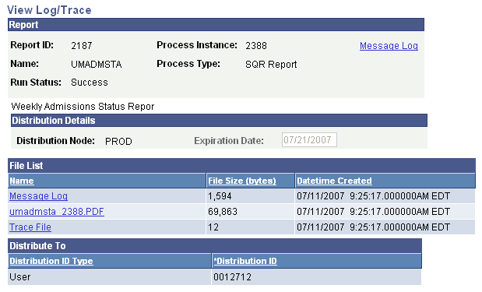

The report appears as follows:
