**Applicant Dashboard Point-In-Time Analysis**

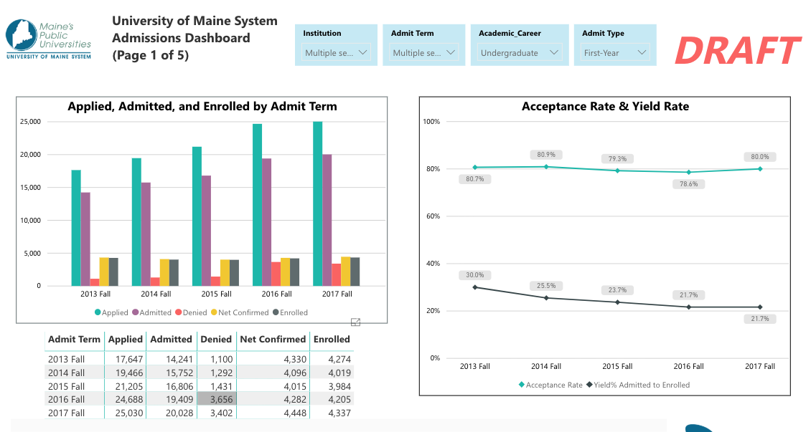

**Develop a date dimension to enable point-in-time comparison in Applicant dashboard**

What is the starting point for inquiry?

* 12 months (e.g., September 4, 2018 for Fall 2019 term)
* 18 months (e.g., March 6, 2018 for Fall 2019 term)
* **Response: 18 months prior to start of term**

What is the reference point?

* 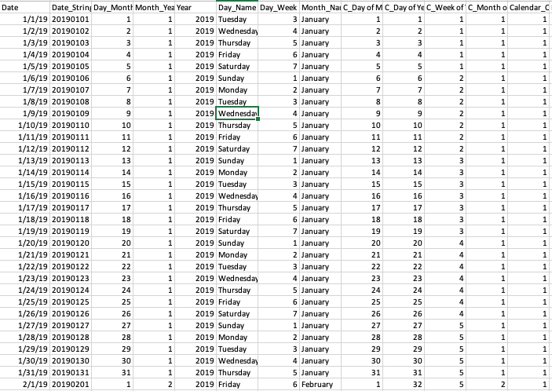Calendar (e.g., week 1, week 2, week 3 of calendar year 2019)
* Start of Term (e.g., September 3 for Fall 2019)

Term Census Date (e.g., October 15 for Fall 2019)

* **Response: Census as reference point, with mechanism to project start of term numbers**

What is the Granularity?

* Weekly (e.g., T-40 weeks or Week 12/52 of the Fall 2019 Admissions Cycle
* Daily (e.g., T-280 days or Day 85 of the Fall 2019 Admissions Cycle)
* **Response: Daily, with hierarchy built in to also do weekly, monthly, quarterly, etc.**