**Create and Configure New MS SQL Server Database**

1. Open Microsoft SQL Server Management Studio 17 (it is under Microsoft SQL Server Tools 17)
2. Right click on Databases -> New Database

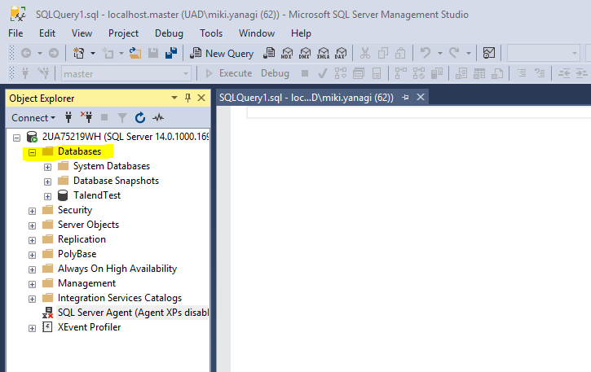

1. Enter Database name (we’ve used TalendTest) and change the initial Size to ‘100’ on ‘TalendTest’ and ‘50’ to ‘TalendTest_log’. Click the square with three dots under Autogrowth.

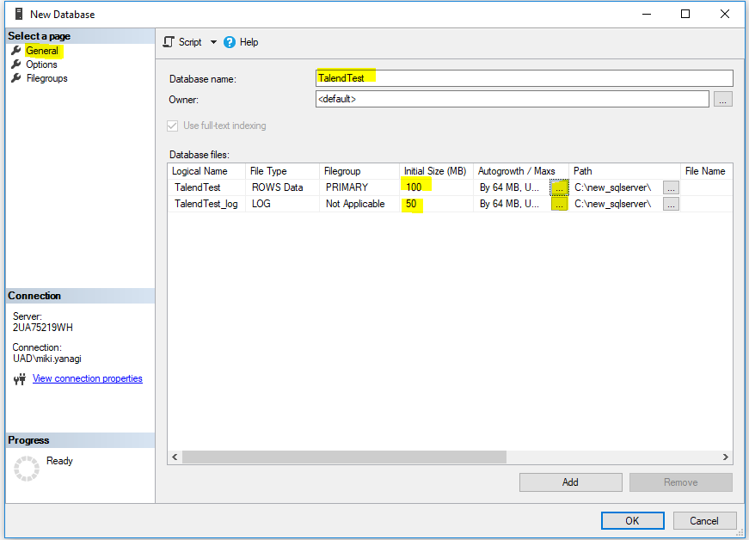

1. Change File Growth to “In Percent”. Do the same for “TalendTest_log”.

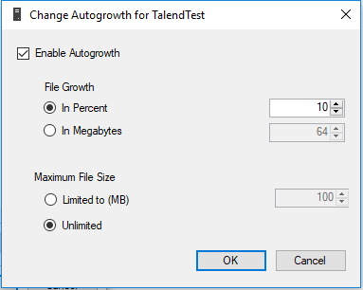

1. Click “Options” and change Recovery model to “Simple” (for pilot project testing phase)

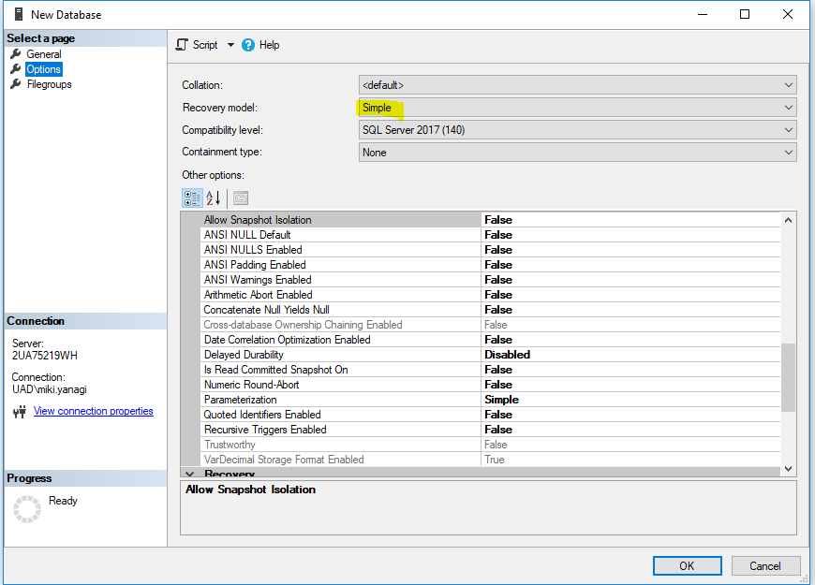

1. Click OK
2. Under “Object Explorer” on the left side bar, open “Security” and right click “Logins” and select “New Login”

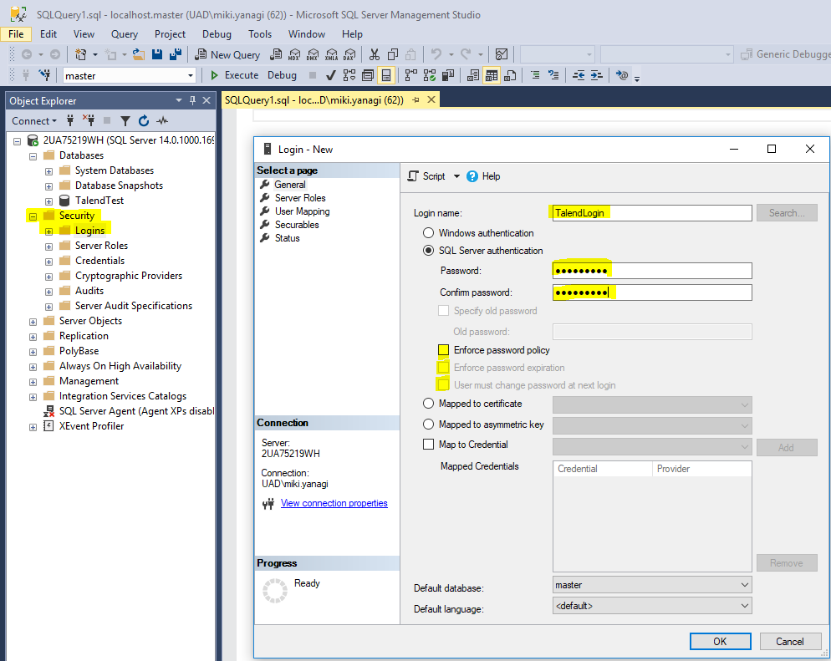

1. Enter Login name. Click “SQL Server authentication” and enter password. The password can be anything, but remember it. Uncheck three boxes under it.
2. Click OK

**Troubleshoot for Test Connection on Talend**

*If you had TCP/IP connection error when you tested the connection, please do the following:

1. Check MS SQL Server Configulation Manager (Go to Start -> Microsoft SQL Server 2017 -> SQL Server 2017 Configulation Manager)

Make sure everything is “enable”

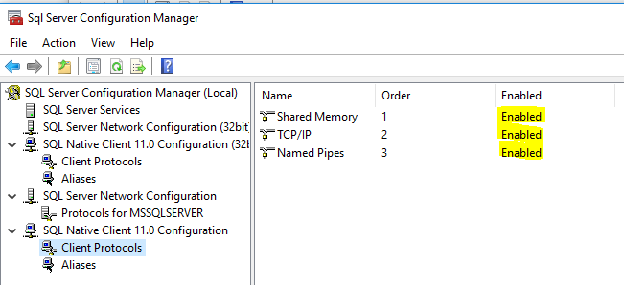

2. Go to “Services” and right click and “Restart” SQL Server

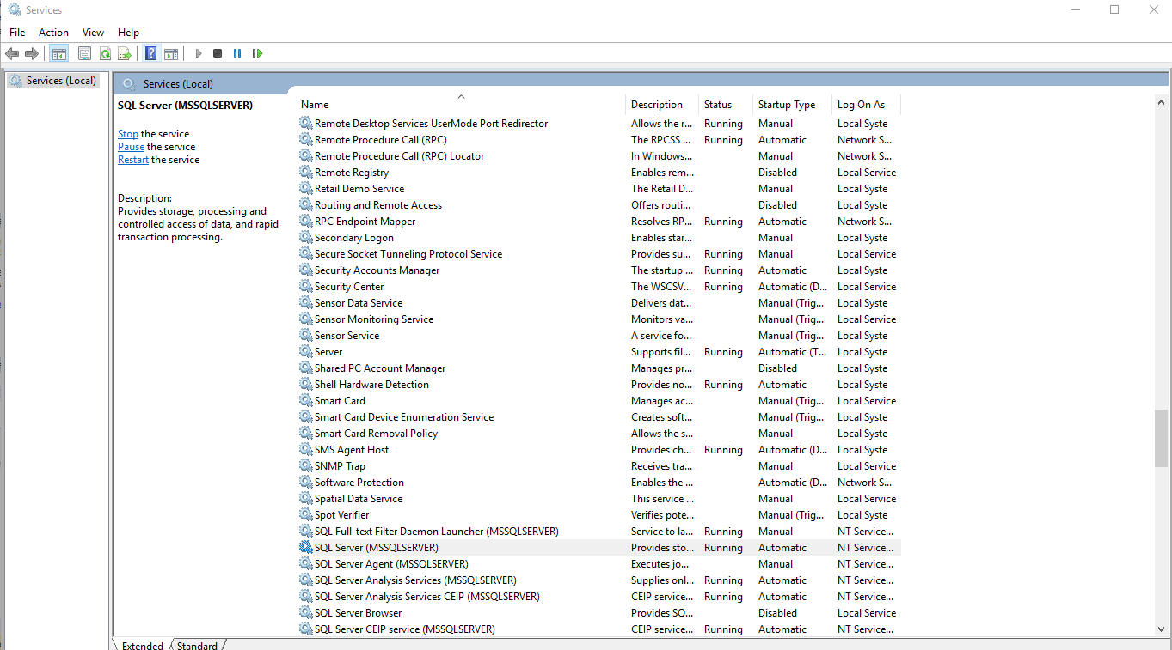

3. Go back to Talend and click “Test Connection”